 |  |  | Center for Commercial Law  School of Law  Avda. Los Castros, s/n (39005 Santander)  Tel.: 942/ 20.12.23 Fax: 942/ 20 12.23  catprocon@unican.es |  |  |  |  | 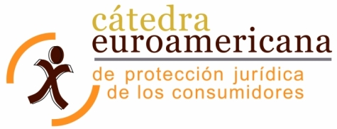

REGISTRATION FORM
II EUROAMERICAN CONFERENCE IN CONSUMER LAW
 | LAST NAME:
 | FIRST NAME: |  |  |  |  | PASSPORT:
 | ADDRESS:
 | CITY: |  |  |  |  | STATE:
 | COUNTRY: |  |  |  |  | P. C. |  |  | PHONE:
 | EDUCATION:
 | PROFESSIÓN:
 | COMPANY:

Additional documents for the registration:
- Registration form
- Copy of valid passport
- Copy of the bank receipt of the fees payment

Registration form and additional documents for the registration should be sent by
- Regular mail to Área de Derecho Mercantil (School of Law, University of Cantabria). See complete address above
- Fax to Área de Derecho mercantil (School of Law. University of Cantabria). See fax number above
- Mail to catprocon@unican.es
- Dominican attendants can also mail to congresoconsumidores@uasd.edu.do

Registration fees:
Payments should be made in the following account number:
2066-0000-17-0200173423. Bank: Caja Cantabria. Account-holder: University of Cantabria.
IBAN: ES03-2066-0000-1702-0017-3423
BIC o SWIFT: CECAESMM066
CONCEPT OF PAYMENT: II Euroamerican conference of consumer law
Additional expenses charged by the bank will not be supported by the organisation.

CANTIDAD INGRESADA:
Members of partner universities of the Euroamerican Chair for Consumer´s Legal Protection | Euros
Others | Euros

